Student’s Name
Professor’s Name
Course
Date
Final Project: Part 3
For my essay, I chose to explore holy trinity because of how it reflects on the Godly features in men (humanity). The holy trinity depicts the kind of life that people should lead according to the expectations of Jesus Christ. The holy trinity is like a community of being, which unites everyone because they understand that they are made in the image and likeness of God.
Each of the examples that I selected represents the concept of holy trinity in various ways as I discuss below. The first example, the Holy Bible: New International Version. This work was published in 1973 by Biblica also known as the International Bible Society. This version of the bible was published to meet the needs of modern Christian believers. Since the old versions used old English, it was important to have a scriptural document that would reflect the need of modern society, by adopting modern English. In the book of Luke chapter 1: 35 it states that “The angel answered, The Holy Spirit will come on you, and the power of the Highest will overshadow you; so the holy one to be born will be called the Son of God (Zondervan).”
Based on a close reading of the chapter, I realized that it effectively represents the concept of the holy trinity. This chapter of the Bible points out the significance of holy trinity and how it is related to the collectiveness of God and the Son, Jesus Christ. The Father and the son are one and the same, which also points out the loving nature of God through His son who eternally dwells within the hearts of the believers.
In the second example, the holy trinity painting that was created by Masaccio in 1427. Masaccio was the first painter in the Renaissance age that first used a linear perspective in his art. The holy trinity, in Santa Maria Novella, was one of his pieces of art that depicted this technique (Zucker & Harris 1). Renaissance started in Florence, Italy where Masaccio came from. During this period, the Catholic Church was experiencing a decline even though religion was still important. Based on aesthetic interpretation, this painting has effectively depicted the beauty of holy trinity by separating them as the Father (God), the Holy Spirit, and Son (Jesus). The painting further depicts the aesthetic qualities of God, which was never depicted before. As Zucker and Harris explain, God was initially represented by a hand (2). Therefore, this painting presents a unique concept of the holy trinity, which aesthetically depicts unity and diversity. I feel that this painting has presented how humanity is modeled in the unity of the holy trinity as it presents how the one and the many are integrated. As depicted in the image (shown below), God is diverse, and so are the people. Since we are created in the likeness of God, we (humanity) also possess the communal identity that He possesses. As such, the holy trinity concept presented in the painting represents a way in which human beings can integrate both unity and diversity without losing their personal identities.
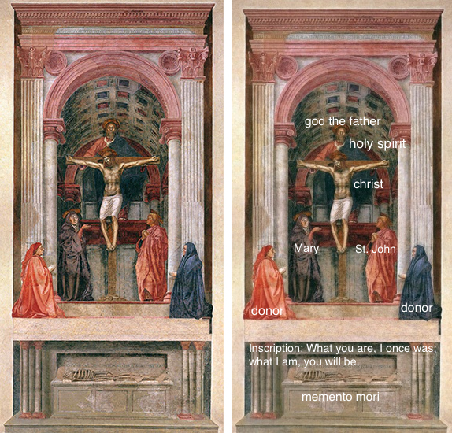
Lastly, the final example, the religion of Christianity further presents the complex nature of the holy trinity. The holy Trinity is the central basis of Christianity. Christianity started at the time of Jesus, especially after his death that he left his 12 disciplines to extend his teachings. After 135 BCE, the tension between Pharisees and the Jews who were barred from Jerusalem became even more intense; thus, creating Christianity movement (Stefon & Spence 1). Furthermore, Stefon and Spence explain that the very center of Christianity starts with the ultimate foundation in the experience of being a Christian (1).
I think that Christianity has effectively represented the concept of the holy trinity. In Christianity, Jesus is considered the embodiment that Christians get to know God through the Holy Spirit. It is through Jesus that people get salvation. This representation has impacted Christians’ understanding of salvation. The reconciliation of the three aspects of the holy trinity as one in many made it clear to me that Christianity has effectively represented this concept. Stefon and Spence explain how the reconciliation of the three dimensions of the holy trinity has inspired the understanding of many religions including the Western metaphysics (1). However, despite the various concerns that emerged during the first years of the Christian era, diversity in the interpretation of the trinity has provided a more clear understanding of the figure of Jesus Christ as the embodiment of Christianity.

Works Cited
Stefon, Stefon., and Spence, Sidney. “The Holy Trinity, The basis for the doctrine of the Trinity” Encyclopaedia Britannica. Accessed December 13, 2019. https://www.britannica.com/topic/Christianity/The-Holy-Trinity
The Holy Bible: New International Version. Zondervan, 1984. Accessed December 13, 2019. https://www.zondervan.com/bibles/niv-bibles/
Zucker, Steven., and Harris, Beth. "Masaccio, Holy Trinity." In Smarthistory, October 10, 2019. Accessed December 13, 2019. https://smarthistory.org/masaccio-holy-trinity/.

